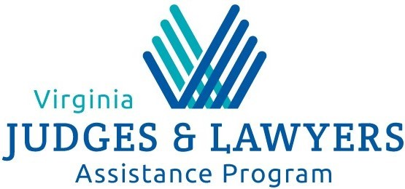

COVID-19 and Well-Being

The Virginia Judges and Lawyers Assistance Program (VJLAP) supports well-being in our profession including health and safety. VJLAP is open and groups and meetings will take place either in person, with distancing, or via electronic means. Please contact your meeting’s organizer for information specific to your group.

We recognize that collateral effects can impact our mental health. We offer these resources as examples to help you understand and manage potential challenges.

Centers for Disease Control and Prevention

The CDC site is likely to offer the most up to date information on the COVID-19 virus (https://www.cdc.gov/). See links to articles “Mental Health and Coping During COVID-19” and “Stigma and Resilience.”
https://www.cdc.gov/coronavirus/2019-ncov/about/coping.html
https://www.cdc.gov/coronavirus/2019-ncov/about/related-stigma.html

Virginia Department of Health
This Virginia resource is continually updated with recommendations and data. http://www.vdh.virginia.gov/surveillance-and-investigation/novel-coronavirus/.
Summary of Resources Discussing COVID 19, Mental Health, and Coping
This article discusses organizational leadership and managing COVID-19 panic.
https://www.forbes.com/sites/janbruce/2020/03/05/the-leaders-guide-to-managing-covid-19-panic/#726c5e5d59ea

This article shares specifics about mental health and panic associated with COVID-19. https://www.thestar.com/news/canada/2020/03/11/coronavirus-and-your-mental-health-two-experts-explain-why-we-panic-and-how-to-cope.html
Author Brian Cuban’s blog “The Addicted Lawyer” offers guidance and options for recovery meetings including In the Rooms, an on-line recovery meeting resource. http://briancuban.com/blog/responsible-recovery-in-pandemic-times/. Isolation can be an issue for many when events are cancelled, and human connections are lost. Brian addresses this at http://briancuban.com/blog/dealing-with-social-isolation/.
This article, published by the American Foundation for Suicide Prevention, reminds us that our mental health can suffer when we lose our sense of control. Find tips for managing our mental health in troubling times. https://afsp.org/taking-care-of-your-mental-health-in-the-face-of-uncertainty/
Here are tips for working remotely from Fast Company: https://www.fastcompany.com/90475330/8-strategies-to-set-up-remote-work-during-the-coronavirus-outbreak.
This article provides tips on managing stress levels in the office. https://www.abajournal.com/news/article/how-do-you-reduce-stress.
This article discusses the connection between anxiety and ethical choices. http://www.psycholawlogy.com/2015/08/10/lawyer-anxiety-self-protective-behavior-ethical-sinkholes-and-professional-responsibility/?utm_source=feedburner&utm_medium=feed&utm_campaign=Feed%3A+Psycholawlogy+%28Psycholawlogy%29

