Addiction is Not a Moral Failure
2021 CLE
The Virginia Judges and Lawyers Assistance Program

Summary:
This session reviews how understanding addiction can benefit members of the legal profession; provides an understanding of addiction from a limbic system/frontal lobe perspective; identifies the role of the brain and amygdala in substance use concerns; and emphasizes the importance of seeing emotion wellness as an essential part of recovery. The session explores the unique vulnerability of members of the legal profession, the impact of social stigma relating to addition, and the distinction between dependence and addiction

CLE Date: May 7, 2021 at 12:00 p.m. (1 hour)

Presenter Biography:
Dr. Stephen Loyd
Dr. Stephen Loyd has decades of experience in internal medicine, mental health, and substance abuse services. He joins us from JourneyPure, a provider for addiction treatment services for patients from across the nation, where he has served as its National Medical Director since 2018. His background includes services as Medical Director and Assistance Commissioner for Substance Abuse services and appointment to the Governor’s Opioid Workgroup and Public Safety Subcabinet, both in Tennessee.
He received his undergraduate degree from University of Tennessee at Knoxville and doctorate at Quillen College of Medicine at East Tennessee State University, where he completed his residency in Internal Medicine. Dr. Loyd has been in long-term recovery from opioids and benzodiazepines since July 9, 2004.

Addiction is Not a Moral Failure
Agenda
- Introduction
  - Objectives
  - Statistics
  - Occupational Risks of Practicing Law
  - Attorney Personality Vulnerabilities
- Understanding Addiction from the Limbic System/Frontal Lobe Perspective
  - Hi-jacking of the Limbic System (Rewards)
  - Brain Healing Takes Time
- Identify the Areas of the Brain Playing a Role in Positive and Negative Reinforcement
  - Substance Use Tricks the Brain’s Rewards System
  - The Brain’s Nucleus Accumbens are Activated by Alcohol
  - Reduced Positive Response
  - Liking versus Wanting
- Understanding the Amygdala’s Role in Driving Substance Use After Periods of Abstinence
  - Voluntary versus Involuntary
  - Tolerance and Compulsion
  - Relapse
- Education, Prevention, and Detection
  - Six Dimensions of Lawyer Well-Being
  - Recognize Signs of Distress
  - Take Action
- Hesitance/Barriers to Seeking Help
  - Stigma
  - Concerns Regarding Privacy or Confidentiality
- Why Care? A well-balanced lawyer is a productive, happy lawyer
  - Self-governing Profession
  - Ethical Responsibility
  - Practical Implications
- VJLAP

Addiction is Not a Moral Failure
Written Materials
-----------------------------------------------------------------------------------------------
- Introduction

  - Objectives:
    - To Provide Members of the Legal Profession with a Better Understand of the Disease of Addiction and How It May Manifest in Themselves, a Colleague, or a Client
    - To Increase the Chances of Establishing Empathetic Relationships with Both Colleagues and Clients

  - Statistics: Several studies have found that members of the legal profession have higher rates of addiction (twice move prevalent than in the general population). Below is an overview of some of that research.
    - “The Prevalence of Substance Use and Other Mental Health Concerns Among American Attorneys.” Journal of Addiction Medicine, February 2016, Volume 10, Issue 1.
      - Substantial rates of behavioral health problems, with more than 20% screening positive for hazardous, harmful, and potentially alcohol-dependent drinking
      - Attorneys in the first 10 years of practice experiencing the highest rates of problematic substance use
      - Working for private firm, probability higher for problematic use
      - Audit Findings:
        - 20.6 % scored at a level consistent with problematic drinking
        - 36.4 % scored as problematic drinking when examining levels and frequency of use (c.f., Physicians = 15%)
        - Higher scores for those working in private firms or bar associations
      - Self-Reporting Concerns
        - 22.6% felt their use of alcohol or substances was a problem sometime during their lives
        - 27.6% reported problematic use prior to law school
        - 14.2% reported problematic use started during law school
        - 43.7 % reported problematic use started within the first 15 years following law school
        - 14.5% reported problematic use started more than 15 years after law school
      - Below is a graph of showing the prevalence of problematic drinking from the 2016 ABA/Hazeldon-Betty Ford Study:
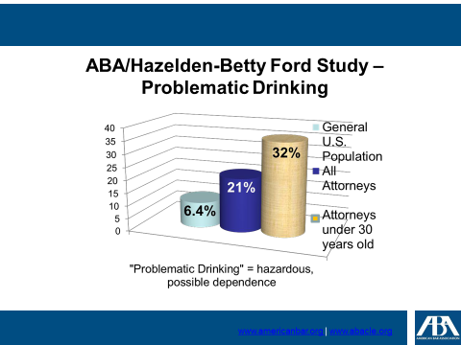
    - Bureau of Justice Statistics
      - Over 60% of individuals arrested test positive for drugs
      - 18% of federal prison inmates and 17% of state prison inmates state that the offense that that are servicing time for were committed to obtain drugs
      - Every year approximately 1.5 million arrests are made for driving under the influence
    - Domestic Relations and Family Law
      - One in three children that entered foster care due to parental substance abuse
      - One in ten children are lives in a household that at least one parent had an alcohol use disorder in the last year.
      - Abuse towards female partners was 2-4 times higher when the male partner has an alcohol abuse issue.
      - In a New York study Substance use preceded domestic assaults 47% of the time and 31% of other assaults

  - The Occupational Risks of Practicing Law: There are certain traits of the profession that put members of the legal profession at a higher rate of risk for developing problematic drinking patterns. Below is a summary of those as presented in The Virginia State Bar President’s Special Committee on Lawyer Well-Being, “The Occupational Risks of Practicing Law” published in May 2019.
    - Physical Risks – those that directly affect a lawyer’s bodily health
      - Sedentary Nature of Work: Lawyers spend most working hours (and off-hours) in the seated position. Mounting evidence suggests that prolonged sitting can be as serious an issue as obesity and smoking, and can pose serious health risks, including an elevated risk of mortality.
      - Managing Long and Unusual Hours: The competing demands of clients, employers, and the judiciary take a toll on a lawyer's time and energy. The result is a profession characterized by long and unusual working hours that can lead to stress, exhaustion and, ultimately, burnout.
      - Sleep Deprivation: The nature and stressors associated with a lawyer's work upset sleep, making legal professionals among the most sleep-deprived in the work force. Too little sleep poses dire health consequences, the effects of which can lead to increased risk of illness and physical injury. Sleep deprivation can also lead to a lapse in judgment, affecting a lawyer's representation of clients and increasing malpractice risk.
      - Working Indoors: A lawyer's indoor working environment disrupts the circadian rhythm, leads to vitamin deficiencies, and may contribute to Seasonal Affective Disorder (SAD).
      - Aging of Lawyers: As lawyers age, our mental and physical capacities decline, creating risks to ourselves, our firms, and our clients. At the same time, other lawyers and legal employers should recognize that aging affects each individual differently, and age is not a litmus test for legal capacity.
    - Mental & Emotional Risks – conditions of law practice that harm psychological well-being
      - Adversarial Nature of Work: The adversarial nature of the legal profession promotes feelings of anger, guilt, and fear that can lead to depression and chronic stress.
      - Individual Work: The individual nature of a lawyer's profession can lead to feelings of isolation. In fact, legal work in general has been considered the loneliest kind of work. Lonely lawyers face a host of health-related risks and impairments, perform poorly, change jobs frequently, and experience greater job dissatisfaction.
      - Professional Demands: The practice of law is a demanding one, and the pressure lawyers face from clients, employers, and the judiciary contribute to virtually every risk outlined in this matrix, along with their incident effects and symptoms.
      - Vicarious Trauma and Managing Others' Problems: Prolonged exposure to our clients' legal problems and dilemmas can be mentally and physically stressful, exhausting and debilitating.
      - The Duty of Confidentiality: Ethical adherence to the duty of confidentiality can cause lawyers to feel isolated, delay necessary case-related tasks, and exacerbate the existing disincentives to seek help.
      - Educational Debt: Law school debt is debilitating. Most law students take out significant debt with the unrealistic and unlikely expectation that they will land a high-paying job. As a result, many will be saddled with crushing monthly payments for the foreseeable future, contributing significantly to overall feelings of stress, anxiety, and disenfranchisement with the profession.
      - Business Management of the Practice of Law: Managing the business component of the practice of law is stressful. New lawyers largely enter practice without any formal financial education, contributing to financial stress.
      - The Need to Display Confidence and Conceal Vulnerability: Law practice and legal education are inherently competitive, discouraging help-seeking behavior as an admission of weakness and incentivizing lawyers to wear a confident façade despite suffering wellness issues.
    - Adaptation Risks – related to the changing nature of law practice in the twenty-first century
      - Changing Legal Paradigms: The nature of law practice has changed dramatically since the digital revolution, with wildly fluctuating market conditions, new business models, and evolving technologies making adaptation challenging, but necessary.
      - Technology Addiction: Ever-connected lawyers who feel obligated to be available at all hours experience reduced attention span and productivity, harm to personal relationships, and risk revealing confidential information through sloppy data use.
      - Lack of Diversity in the Legal Profession: Diverse and inclusive working environments foster lawyer wellness. A lack of diversity, however, can lead to isolation, a sense of exclusion, and ultimately poor performance and a lack of autonomy.
      - External Pressures on Lawyer Independence: Economic pressures and changing market dynamics, such as the rise of alternative legal business structures and attorney-client matching services (ACMSs), are incentivizing attorneys to compromise their independence, risking professional sanction and harm to the rule of law.
    - Self-Actualization Risks – those that prevent lawyers from flourishing or reaching a state of contentment between their professional, social, and personal lives
      - Losing Control of Professional Destiny: Becoming trapped in a particular area of law or type of legal employment the lawyer does not enjoy is at best unfulfilling and at worst actively detrimental to a lawyer's health and well-being.
      - Values Conflict with Client or Practice Setting: Lawyers carrying out instructions or practicing in a subject area contrary to their personal beliefs experience cognitive dissonance that can harm not only their practices, but also their sense of personal integrity.
      - The Expectations-Reality Gap in Law Practice: Many people enter law school with certain expectations about life as an attorney, only to have those expectations disappointed by practical realities, resulting in career regret and a sense of feeling trapped.

  - Attorney Personality Vulnerabilities:
    - Adversarial nature fosters stress response
    - Tremendous fear of being perceived as weak by others
    - Fear of being taken advantage of if perceived to be weak
    - Competition creates stress
    - Expectations of clients are unrealistic
    - Decline of professionalism, collegiality: “dog eat dog” mentality
    - Frustration of long, drawn out struggle with no clear victory
    - Inability to separate professional from personal life
    - Overachievers/Competitive
    - Perfectionists: Organization, details, fear of malpractice
    - Compartmentalized: Helps with focus but dangers relationships
    - Independent: Taught that we can think our way out of any situation
    - Work-focused: Limited or zero concept of “enough is enough”
    - Risk Adverse
    - Externally motivated: Directed towards external rewards (e.g., money, honors, avoidance of guilt or fear, or pleasing/impressing others)

  - How Understanding Addiction Can Benefit Members of the Legal Profession: Dependence versus Addiction
    - Dependence- once the drug is stopped, a predictable physiological withdrawal syndrome occurs
    - Addiction- the compulsive use, loss of control and continued use despite adverse consequences; hallmark is cravings.

- Understanding Addiction from the Limbic System/Frontal Lobe Perspective

  - Hi-Jacking of the Limbic System (Rewards): “How Addiction Hijacks the Brain,” Harvard Mental Health Letter, July 2011.

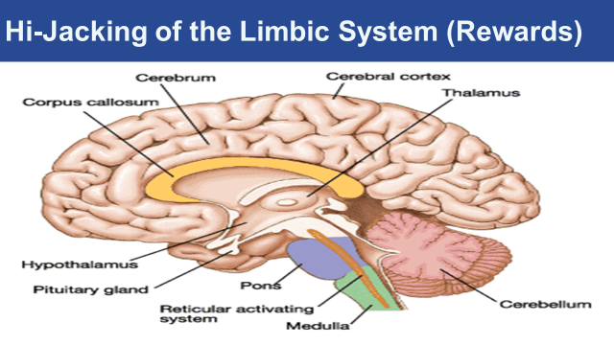
    - The Limbic System: The limbic system is a "collective term denoting a heterogeneous array of brain structures at or near the edge of the medial wall of the cerebral hemisphere, in a particular the hippocampus, amygdala, and fornicate gyrus." (Childress, 1999). The limbic system is responsible for creating your feelings and motivation. Your feelings supply the contexts for your sensory and motor activities and can alter how one perceives the world and behaves in it. This portion of the brain physically connects the survival oriented brain stem with the cognitively oriented cortex.
    - Drugs/Alcohol and the Limbic System: All drugs that people abuse all change the way the limbic system works. Drugs disrupt the careful modulation of feelings and motivations that underlie normal behavior. When these feelings lose touch with reality, the person receives artificial relief, pleasure, contentment, and relaxation take over
    - The Brain Reward System: The Brain Reward System is a specific limbic circuit that generates the feelings of pleasure. This system originates in a group of neurons that are located in the mid brain (called the ventral tegmental area, or VTA). These neurons then connect to a variety of places within the limbic system, but the important connection is to the nucleus accumbens in the basal ganglia. The basal ganglia are a large, complex set of structures within the limbic system that function in generating movements, some cognitive functions, emotional and motivational activities. When a drug activates the VTA neurons, these neurons release dopamine into the nucleus accumbens and the person feels pleasure.

  - Brain Healing Takes Time
    - Post-Addiction Brain Recovery: How the brain recovers from addiction is an exciting and emerging area of research. There is evidence that the brain does recover; the image below shows the healthy brain on the left, and the brain of a patient who misused methamphetamine in the center and the right. In the center, after one month of abstinence, the brain looks quite different than the healthy brain; however, after 14 months of abstinence, the dopamine transporter levels (DAT) in the reward region of the brain (an indicator of dopamine system function) return to nearly normal function (Volkow et al., 2001).
    - Current Research: There is limited research on the brain’s recovery from alcohol and marijuana use. However, recent studies have shown that some recovery does take place. For example, one study found that adolescents that became abstinent from alcohol had significant recovery with respect to behavioral disinhibition and negative emotionality (Hicks et al., 2012). Lisdahl and colleagues propose that this could mean that some recovery is occurring in the prefrontal cortex after a period of abstinence. Furthermore, other research has found that number of days abstinent from alcohol was associated with improved executive functioning, larger cerebellar volumes, and improved short-term memory.
    - Initial Findings: While promising, this field of research is in its infancy and there have been conflicting results that instead show minimal to no recovery from cognitive deficits. This is especially true for studies evaluating the brain’s recovery from marijuana use, specifically in regards to IQ. On the other hand, some studies have shown that former marijuana users demonstrate increased activation in parts of the brain associated with executive control and attention. Whether this is associated with the compensatory response or brain recovery has yet to be determined.
    - Brain Healing Happens, With Time: What is clear is that alcohol and marijuana do have neurotoxic effects and that, to some degree, this damage can be reversed. There is minimal evidence on how we can improve brain recovery from substance use, but emerging literature suggests that exercise as an intervention may improve brain recovery. Physical activity has been shown to improve brain health and neuroplasticity. In previous studies of adults, physical activity has improved executive control, cerebral blood flow, and white matter integrity. While none of these interventions have been done in adolescent alcohol or marijuana users, this approach is promising and should be investigated further.
    - Brain scans of activity for non-addicted person, and a person post-addiction with 10 and 100 days of abstinence.
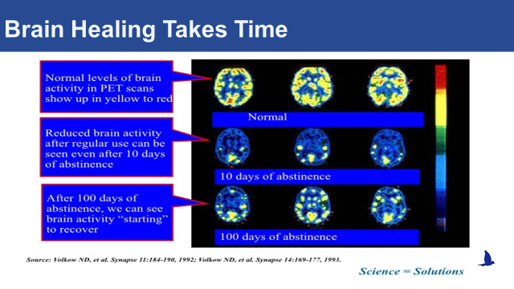

- Identify the Areas of the Brain Playing a Role in Positive and Negative Reinforcement

  - Substance Use Tricks the Brain’s Rewards System: The brain can experience pleasure from all sorts of things we like to do in life; eat a piece of cake, have a sexual encounter, play a video game. The way the brain signals pleasure is through the release of a neurotransmitter (a chemical messenger) called dopamine into the nucleus accumbens, the brain’s pleasure center. This is generally a good thing; it ensures that people will seek out things needed for survival. But drugs of misuse, such as nicotine, alcohol, and heroin, also cause the release of dopamine in the nucleus accumbens, and in some cases these drugs cause much more dopamine release than natural, non-drug rewards.

  - The Brain’s Nucleus Accumbens are Activated by Alcohol: Addictive drugs can provide a shortcut to the brain’s reward system by flooding the nucleus accumbens with dopamine. Additionally, addictive drugs can release 2 to 10 times the amount of dopamine that natural rewards do, and they do it more quickly and reliably.

  - Reduced Positive Response: Over time, drugs become less rewarding, and craving for the drug takes over. The brain adapts to the effects of the drug (an effect known as tolerance), and because of these brain adaptations, dopamine has less impact. People who develop an addiction find that the drug no longer gives them as much pleasure as it used to, and that they have to take greater amounts of the drug more frequently to feel high.

  - Liking versus Wanting: There is a distinction between liking and wanting the drug; over time, the liking decreases and the wanting increases. Individuals with a substance use disorder continue to seek and use the substance, despite the negative consequences and tremendous problems caused for themselves and for their loved ones, because the substance allows them to simply feel normal.

- Understanding the Amygdala’s Role in Driving Substance Use After Periods of Abstinence

  - Voluntary versus Involuntary
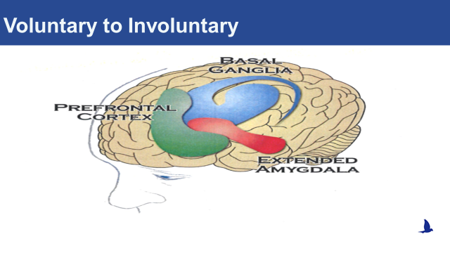
  - Tolerance and compulsion:
    - Addictive drugs, for example, can release two to 10 times the amount of dopamine that natural rewards do, and they do it more quickly and more reliably. In a person who becomes addicted, brain receptors become overwhelmed. The brain responds by producing less dopamine or eliminating dopamine receptors — an adaptation similar to turning the volume down on a loudspeaker when noise becomes too loud
    - As a result of these adaptations, dopamine has less impact on the brain's reward center. People who develop an addiction typically find that, in time, the desired substance no longer gives them as much pleasure. They have to take more of it to obtain the same dopamine "high" because their brains have adapted — an effect known as tolerance.
    - At this point, compulsion takes over. The pleasure associated with an addictive drug or behavior subsides — and yet the memory of the desired effect and the need to recreate it (the wanting) persists. It's as though the normal machinery of motivation is no longer functioning.
    - The learning process mentioned earlier also comes into play. The hippocampus and the amygdala store information about environmental cues associated with the desired substance, so that it can be located again. These memories help create a conditioned response — intense craving — whenever the person encounters those environmental cues.
    - Cravings contribute not only to addiction but to relapse after a hard-won sobriety. A person addicted to heroin may be in danger of relapse when he sees a hypodermic needle, for example, while another person might start to drink again after seeing a bottle of whiskey. Conditioned learning helps explain why people who develop an addiction risk relapse even after years of abstinence.

  - Relapse: About 40% to 60% of people with a drug addiction experience at least one relapse after an initial recovery. While this may seem discouraging, the relapse rate is similar to that in other chronic diseases, such as high blood pressure and asthma, where 50% to 70% of people each year experience a recurrence of symptoms significant enough to require medical intervention.

- Education, Prevention, and Detection
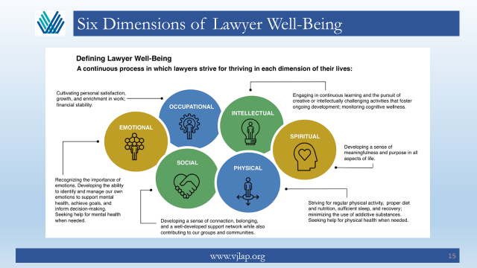

  - Recognize Signs of Distress
    - Poor work performance: Late to work, missing appointments/hearings, deadlines, filings.
    - Changes in appearance: Weight loss/gain, changes in personal hygiene, disheveled cloths.
    - Scheduling difficulties: Long lunches, unexplained absences from work.
    - Mood changes: Tearfulness, crying, statements that range from depressed to grandiose, defensiveness, quick temper.
    - Relationship difficulties: Friends, family, colleagues
    - Attention: Low concentration, off-topic outbursts

  - Take Action (Trust your instincts; Make sure you are not minimizing the issues)
    - Recognize: The signs in yourself or in a colleague of distress
    - Acknowledge: Do not ignore it
    - Engage: Talk, actively listen, have empathy
    - Help: Plan and take deliberate action for improved wellness; avoid enabling
    - Monitor: If the symptoms exist for longer than two weeks, seek medical or mental health treatment

- Hesitancy/Barriers to Seeking Help

  - Stigma
    - Not wanting others to find out they needed help – Stigma
    - Fear of being judged
    - Fear it will harm their professional rep.
    - Fear it would impact their license
    - Think they can solve the problem themselves
    - Because of denial about the existence or severity of their problem

  - Concerns regarding privacy or confidentiality

V. Why Care? A well-balanced lawyer is a productive, happy lawyer.

- Self-governing profession
  - Protect the public
  - Protect the profession

- Ethical responsibility
    - Competence (mental, emotional, and physical)
    - Impairment
    - Malpractice
    - Discipline

- Practical Implications
  - Productivity
  - Reputation

- VJLAP
