CLE WRITTEN MATERIALS
The Intersection of Competence, Ethics, and Well-Being
October 27, 2021
Virginia Judges and Lawyers Assistance Program

WRITTEN MATERIALS
OUTLINE
- Legal Ethics
  - Duty of Competence
    - Elements
      - Legal knowledge (keep abreast of changes in the law and its practice; continuing study and education);
      - Skill (including benefits and risk associated with relevant technology);
      - Thoroughness;
      - Preparation reasonably necessary; and
      - Mental, emotional, and physical ability reasonably necessary for the representation.
    - Rules of Professional Conduct, Preamble, and Scope
      - Rules of Professional Conduct, Preamble
        - …In all professional functions a lawyer should be competent, prompt and diligent. A lawyer should maintain communication with a client concerning the representation. A lawyer should keep in confidence information relating to representation of a client except so far as disclosure is required or permitted by the Rules of Professional Conduct or other law. …
        - … Every lawyer is responsible for observance of the Rules of Professional Conduct. A lawyer should also aid in securing their observance by other lawyers. Neglect of these responsibilities compromises the independence of the profession and the public interest which it serves.
        - Lawyers play a vital role in the preservation of society. The fulfillment of this role requires an understanding by lawyers of their relationship to our legal system. The Rules of Professional Conduct, when properly applied, serve to define that relationship. …
      - Rules of Professional Conduct, Scope
        - … Compliance with the Rules, as with all law in an open society, depends primarily upon understanding and voluntary compliance, secondarily upon reinforcement by peer and public opinion and finally, when necessary, upon enforcement through disciplinary proceedings. The Rules do not, however, exhaust the moral and ethical considerations that should inform a lawyer, for no worthwhile human activity can be completely defined by legal rules. The Rules simply provide a framework for the ethical practice of law. …
        - … Failure to comply with an obligation or prohibition imposed by a Rule is a basis for invoking the disciplinary process. The Rules presuppose that disciplinary assessment of a lawyer's conduct will be made on the basis of the facts and circumstances as they existed at the time of the conduct in question and in recognition of the fact that a lawyer often has to act upon uncertain or incomplete evidence of the situation. Moreover, the Rules presuppose that whether or not discipline should be imposed for a violation, and the severity of a sanction, depend on all the circumstances, such as the willfulness and seriousness of the violation, extenuating factors and whether there have been previous violations. …
  - Ethical Requirements Related to Competency
    - Competence is inherent in any notion of Professionalism, and is expressed in Rule 1.1:
      - A lawyer shall provide competent representation
      - That duty includes: all legal knowledge, skill, thoroughness and preparation required to provide the competent representation
      - Inherent too in the notion of Competence is a lawyer’s mental, emotional and physical well-being [Note 7], without which a lawyer cannot provide competent representation
    - Professionalism requires a clear statement of the Scope of Representation which is controlled by Rule 1.2 of the Rules:
      - A lawyer shall abide by the client’s decision in: determining whether or not to accept a settlement, to enter a plea, to ask for a jury or to permit the client to testify.
      - A lawyer can limit the scope of representation with the agreement of the client, and take any action impliedly authorized by that agreement; but
      - A lawyer shall not counsel a client to engage in, or assist a client in engaging in conduct known to be illegal or fraudulent.
    - Professionalism includes Diligence per Rule 1.3:
      - A lawyer shall act with reasonable diligence and promptness in the representation.
      - She shall not intentionally fail to perform duties consistent with the agreement of representation, but may withdraw in accordance with the Rules
    - Client Communication – Expressed explicitly in Rule 1.4 and implicitly throughout the Rules
      - A lawyer shall keep client reasonably informed and comply with reasonable requests for information
        - A lawyer shall explain a matter to the extent reasonably necessary for client to make an informed decision.
        - Most of the Rules are subject to varying degrees of application depending upon the client’s consent after consultation.
        - Most fee disputes could be resolved with clear communication in advance of the representation (or shortly thereafter) Rule 1.5
      - Confidentiality of Communication – Rule 1.6 – A lawyer shall not reveal:
        - Information protected by the attorney-client privilege
        - Information gained in the representation which client has requested be held inviolate (or which would be detrimental/embarrassing to the client), and
        - Except, if client agrees after consultation.
  - Duty to Withdraw/Decline Representation
    - (a) … a lawyer shall not represent a client or, where representation has commenced, shall withdraw from the representation of a client if: … (2) the lawyer's physical or mental condition materially impairs the lawyer's ability to represent the client;
    - Comment [1] A lawyer should not accept or continue representation in a matter unless it can be performed competently, promptly, without improper conflict of interest and to completion.
  - Duty to Report
    - Rule 8.3 Reporting Misconduct
      - (a) A lawyer having reliable information that another lawyer has committed a violation of the Rules of Professional Conduct that raises a substantial question as to the lawyer’s honesty, trustworthiness or fitness as a lawyer shall inform the appropriate professional authority
      - (d) This Rule does not require disclosure of information otherwise protected by Rule 1.6 or information gained by a lawyer or judge who is a member of an approved lawyer’s assistance program, or who is otherwise cooperating in a particular assistance effort, when such information is obtained for the purposes of fulfilling the recognized objectives of the program.
    - Comment
      - [1] Self-regulation of the legal profession requires that members of the profession initiate disciplinary investigation when they know of a violation of the Rules of Professional Conduct. Lawyers have a similar obligation with respect to judicial misconduct. An apparently isolated violation may indicate a pattern of misconduct that only a disciplinary investigation can uncover. Reporting a violation is especially important where the victim is unlikely to discover the offense.
      - [4] The duty to report professional misconduct does not apply to a lawyer retained to represent a lawyer or judge whose professional conduct is in question. Such a situation is governed by the rules applicable to the client-lawyer relationship.
      - [5] Information about a lawyer's or judge's misconduct or fitness may be received by a lawyer in the course of that lawyer's participation in or cooperation with an approved lawyers or judges assistance program. In that circumstance, providing for the confidentiality of such information encourages lawyers and judges to seek treatment through such program. Conversely, without such confidentiality, lawyers and judges may hesitate to seek assistance from these programs, which may then result in additional harm to their professional careers and additional injury to the welfare of clients and the public. The duty to report, therefore, does not apply to a lawyer who is participating in or cooperating with an approved lawyer assistance program such as the Virginia Bar Association's Committee on Substance Abuse and who learns of the confidences and secrets of another lawyer who is the object of a particular assistance effort when such information is obtained for the purpose of fulfilling the recognized objectives of the program. Such confidences and secrets are to be protected to the same extent as the confidences and secrets of a lawyer's client in order to promote the purposes of the assistance program. On the other hand, a lawyer who receives such information would nevertheless be required to comply with the Rule 8.3 reporting provisions to report misconduct if the impaired lawyer or judge indicates an intent to engage in illegal activity, for example, the conversion of client funds to personal use.
    - ABA Formal Opinion 03-429:
- “… if partners in the firm and the supervisory lawyer reasonable believe that the previously impaired attorney has resolved a short-term psychiatric problem that made the lawyer unable to represent clients competently and diligently, there is nothing to report. Similarly if the firm is able to eliminate the risk of future violations of the duties of competence and diligence under the Model Rules through close supervision of the lawyers work, it would not be required to report the lawyer’s violation. However…..
- “…if, on the other hand, a lawyers mental impairment renders the lawyer unable to represent clients competently, diligently, and otherwise as required by the Model Rules and he nevertheless continues to practice, partners in the firm or the supervising attorney must report the violation” (page 5).
  - Duty of Partners/Supervisors
    - Rule 5.1 Responsibilities of Partners and Supervisory Lawyers
      - (a) A partner in a law firm, or a lawyer who individually or together with other lawyers possesses managerial authority, shall make reasonable efforts to ensure that the firm has in effect measures giving reasonable assurance that all lawyers in the firm conform to the Rules of Professional Conduct.
      - (b) A lawyer having direct supervisory authority over another lawyer shall make reasonable efforts to ensure that the other lawyer conforms to the Rules of Professional Conduct.
      - (c) A lawyer shall be responsible for another lawyer's violation of the Rules of Professional Conduct if: … (2) the lawyer is a partner or has managerial authority in the law firm in which the other lawyer practices, or has direct supervisory authority over the other lawyer, and knows of the conduct at a time when its consequences can be avoided or mitigated but fails to take reasonable remedial action.
      - Comment
        - [5] … Appropriate remedial action by a partner would depend on the immediacy of the partner's involvement and the seriousness of the misconduct. The supervisor is required to intervene to prevent avoidable consequences of misconduct if the supervisor knows that the misconduct occurred. Thus, if a supervising lawyer knows that a subordinate misrepresented a matter to an opposing party in negotiation, the supervisor as well as the subordinate has a duty to correct the resulting misapprehension.
        - [6] Professional misconduct by a lawyer under supervision could reveal a violation of paragraph (b) on the part of the supervisory lawyer even though it does not entail a violation of paragraph (c) because there was no direction, ratification or knowledge of the violation.
        - [7] Apart from this Rule and Rule 8.4(a), a lawyer does not have disciplinary liability for the conduct of a partner, associate or subordinate. Whether a lawyer may be liable civilly or criminally for another lawyer's conduct is a question of law beyond the scope of these Rules.
    - Rule 5.3 Responsibility Regarding Nonlawyer Assistants
      - With respect to a nonlawyer employed or retained or associated with a lawyer:
(c) a lawyer shall be responsible for conduct of such a person that would be a violation of the Rules of Professional Conduct if engaged in by a lawyer if: … (2) the lawyer is a partner or has managerial authority in the law firm in which the person is employed, or has direct supervisory authority over the person, and knows or should have known of the conduct at a time when its consequences can be avoided or mitigated but fails to take reasonable remedial action.
      - Committee Commentary: The Committee inserted the phrase "or should have known" in Rule 5.3(c)(2) to reflect a negligence standard. The Committee also deemed it appropriate to add the language in the last sentence of the Comment to cover such recognized and accepted activities as those described.
      - ABA Formal Opinion 03-429: “The firm’s paramount obligation is to take steps to protect the interests of clients. The first step may be to confront the impaired lawyer with the facts of his impairment and insist upon steps to assure that clients are represented appropriately notwithstanding the lawyer’s impairment. Other steps may include forcefully urging the impaired lawyer to accept assistance to prevent future violations or limiting the ability to handle matters or deal with clients” (page 4).
- LEO 1886
      - Duties of supervising attorneys and partners in a law firm to take remedial measures upon discovery of potential impairment of attorney within the firm. Has practical guidance for the firm to take action to protect clients’ interests and address impairment, including contacting VJLAP.
- LEO 1887
      - Duties when a lawyer over whom no one has supervisory authority is impaired.
      - 8.3(a) only requires a report if there is reliable information that another has committed an RPC violation that raises a substantial question as to the lawyer’s honesty, trustworthiness, or fitness to practice law.

- Definition of Well-Being for Lawyers
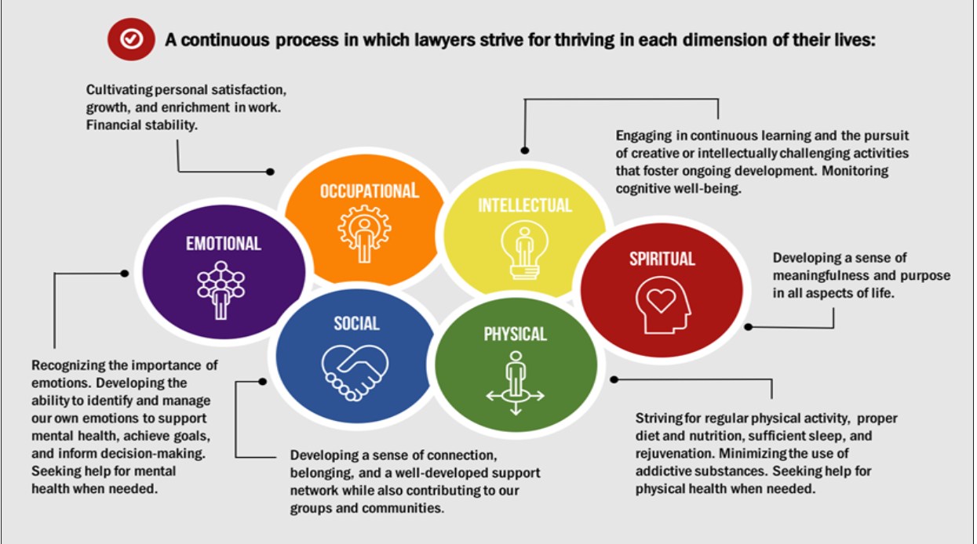

- Organizational Culture: A culture characterized by trust, honesty, and fairness.
- Psychological Support: Supervisors and coworkers are supportive of organizational members’ psychological and mental health concerns, and respond appropriately.
- Clear Leadership & Expectations: There is effective leadership and support that helps organizational members know what they need to do, how their work contributes to the organization, and whether there are impending changes.
- Civility & Respect: Employees are respectful and considerate in their interactions with one another, as well as with clients and the public.
- Psychological Competencies & Requirements: There is a good fit between employees’ interpersonal and emotional competencies and the requirements of the position they hold.
- Growth & Development: Employees receive encouragement and support in the development of their interpersonal, emotional, and job skills.
- Recognition & Reward: There is appropriate acknowledgment and appreciation of organizational members’ efforts in a fair and timely manner.
- Involvement & Influence: Organizational members are included in discussions about how their work is done and how important decisions are made.
- Workload Management: Tasks and responsibilities can be accomplished successfully within the time available.

- Signs and Symptoms of Impairment
- ABA: Top 10 Necessary Skills
  - Keeping confidentiality.
  - Arriving on time.
  - Honoring commitments.
  - Integrity and trustworthiness.
  - Treating others with courtesy and respect.
  - Listening attentively and respectfully.
  - Responding promptly.
  - Diligence.
  - Having a strong work ethic.
  - Paying attention to detail.
- Impact of Mental Health and Substance Use Concerns
  - Mental impairment does not lessen a lawyer’s obligation to provide clients with competent representation
  - Lawyers who suffer from substance abuse, mental illness, physical illness, and personal problems may have impairment in their ability to provide competent services (they may be undertaking work they do not have the competency to do despite possessing the requisite learning and skill).
  - Depressed, anxious, substance abusing lawyers may struggle with follow through, attention, integrity, trustworthiness, responding promptly, diligence.
  - Sometimes these problems mask their ability to understand their limitations and sometimes sheer economic necessity compels them to undertake matters beyond their competency.
  - There is an interface between these struggles and ethical violations.
- Examples of Problematic Behaviors (Connected to Lawyer Mental Health or Substance Use Concerns with Potential Ethical Consequences)
- Practice-based
  - Missed deadlines
  - Last minute requests for continuances
  - Frequent absenteeism
  - Sub-par work product
  - Lack of communication with clients and/or colleagues
  - Failure to advocate for client’s interests
  - Late for or missed appointments and/or hearings
  - Errors in fiscal management
  - False representations
- Attorney signs
  - Acting different from prior functioning
  - Socially withdrawn
  - Procrastination
  - Unpredictable and frequent mood swings
  - Unwarranted anger or hostility
  - Blaming others for personal failings
- Detection of Potential Impairment
    - Initial indication may be raised in Bar Complaint, e.g., “My attorney hasn’t returned my calls for months and didn’t show up for court Monday.”
    - Misconduct allegations typically implicate RPCs 1.1 (Competence), 1.3 (Diligence), and 1.4 (Communication).
    - Allegations and/or evidence may implicate misrepresentations to clients (RPC 8.4) and/or failure to return unearned fees or other trust account issues (RPCs 1.15, 1.16, and 8.4).
- Impact of the problem:
  - Human Toll
    - Health impacts on the individual
    - Damage to families and relationships
    - Loss of career and financial problems
    - Serious disability or death
  - Work Environment
    - Culture and morale
    - Direct impact on colleagues
    - Reputation/ trust
    - Clients and business
  - Productivity
    - Individual and Team work product
    - Management time
  - Financial
    - Human capital
    - Unwanted turnover
    - Legal, work comp. or disability claims
    - Lawsuits/ malpractice
- Business Case for Taking Action
- Malpractice avoidance and ethical adherence
- Firm image and overall customer satisfaction
- Delivery of quality, effective client service
- Individual employee performance, development, and retention
- Collective culture and morale
- Turnover and healthcare costs.

- Prevention and Early Intervention
- Encourage potentially impaired attorneys to seek assistance to prevent Misconduct and VSB intervention. Identify and assist before issues “materially impair the attorney’s fitness to practice law.”
- Professional Self-Regulation
  - The Preamble to the Rules of Professional Conduct (Rules) reminds us of our duties to the profession and to the public. “The legal profession’s relative autonomy carries with it special responsibilities of self-government. The profession has a responsibility to assure that its regulations are conceived in the public interest and not in furtherance of parochial or self-interested concerns of the bar. Every lawyer is responsible for observance of the Rules of Professional Conduct. A lawyer should also aid in securing their observance by other lawyers. Neglect of these responsibilities compromises the independence of the profession and the public interest which it serves.”
  - The privilege of being a self-governing, relatively autonomous, profession carries with it the responsibility of assuring that our behavior conforms to the Rules and serves the public interest.
  - “Compliance with the Rules, as with all law in an open society, depends primarily upon understanding and voluntary compliance, secondarily upon reinforcement by peer and public opinion and finally, when necessary, upon enforcement through disciplinary proceedings.” Preamble, Rules of Professional Conduct.
  - Additionally lawyers should assist each other in upholding the Rules. The Preamble instructs, “Neglect of these responsibilities compromises the independence of the profession and the public interest it serves.”
  - Rules are a baseline, not a ceiling: “Many of a lawyer's professional responsibilities are prescribed in the Rules of Professional Conduct, as well as substantive and procedural law. However, a lawyer is also guided by personal conscience and the approbation of professional peers. A lawyer should strive to attain the highest level of skill, to improve the law and the legal profession, and to exemplify the legal profession's ideals of public service.”
- Lawyer Hesitance:
  - Most do not receive treatment services
    - MH: 37% yes; 63% no
    - Addiction: 7% yes; 93 % no
  - Lawyers are hesitant to seek help for their mental health or substance use problems.
- Concerns about privacy or confidentiality
- Not wanting others to find out - Stigma
      - Fear of being judged
      - Fear it will harm their professional reputations
      - Fear it would impact their license
- Think they can solve the problem themselves
- Denial about the existence or severity of the problem
- Fighting Stigma
- Poor mental health is a medical condition; attorneys with mental health challenges can thrive in the profession.
- Profession-wide collaboration:
  - Change the messaging. There is no shame in mental illness. There is no shame in asking for help. There is no shame in the struggle to wellness.
- Asking for help is the smart thing to do.
- Acknowledge the issues.
  - Educate
- Profession-wide summits for health and wellness
- Awareness of the impact of obsessing over a desire for perfection.
- Prevent
- Develop strategies for improving well-being
- Promote health and wellness activities
- Refer
- To VJLAP often and early – prior to, during, or after discipline
- Early identification is the key and a duty
- Often, by the time an attorney is referred into a program, they are severely impaired which may negatively impact the outcome.

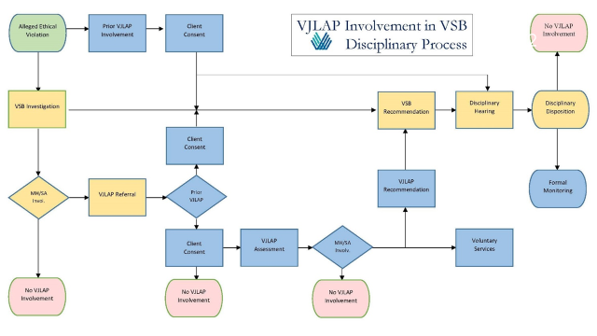
- Resources
  - The Virginia Judges and Lawyers Assistance Program
  - The National Suicide Prevention Line. This hotline provides free, confidential support 24/7 to people in distress across the United States. Call 1-800-273-TALK (8255) for support.
  - The SAMHSA Helpline. SAMHSA’s National Helpline is a free, confidential information service that provides treatment and support referrals 24/7 to people facing mental illness and addictions. Call 1-800-662-HELP (4357) for support.
  - Crisis Text Line. Crisis Text Line provides free, confidential support via text message 24/7 to those in crisis situations. Text HOME to 741741 for support.
  - The Trevor Project. The Trevor Project provides free, confidential support 24/7 to LGBTQ youth via a helpline, text and online instant messaging system. Call 1-866-488-7386 for support.
  - The Veterans Crisis Line. The Veterans Crisis line provides free, confidential support 24/7 to veterans, all service members and their family and friends in times of need. Call 1-800-273-8255 and press 1 or text 838255 for support
  - Mental Health First Aid (available through VJLAP).
  - The Virginia State Bar report, “The Occupational Risks of the Practice of Law”: This report outlines different risks that attorneys may face during their careers, including physical, mental and emotional, adaptation, and self-actualization risks. The report begins with a helpful matrix, which outlines each risk factor along with individual and organizational practice pointers.

